**Crew Member in Training**

**Starlight Cruises**

Oct. 2016 - Sep. 2014

• Completed 18 months of training

Copywright by ResumeViking 2022

[60 Word Templates](https://www.resumeviking.com/templates/word/)

[Resume Tool](https://resume.io/resume-templates/?id=cpdokyF1)

**Service Crew**

**Mary Queen Cruiseliners**

Jan. 2018 - Dec. 2020

* ● Provided high standards of customer service during high-volume and fast-paced operations
* ● Handled cash and credit card transactions quickly and accurately
* ● Assisted management with inventory control and stock ordering
* ● Maintained positive attitude and resolved customer complaints promptly and professionally
* ● Took initiative to find extra tasks when scheduled duties were completed
* ● Cross-trained new crew members

**Service Crew**

**Food Emporium**

Dec. 2016 - Nov. 2018

● Handle escalated customer service complaints, always ensuring customer satisfaction to provide customer satisfaction, increased retention and customer loyalty.

● Prepare food and maintenance of kitchen and restaurant floor to ensure compliance with the Food and Drug Administration at all times.

**E D U C A T I O N**

Diploma in Food Sciences / Florida University / Jacksonville 2000 - 2005

Certificate in Customer Services / Texas

University / Austin 2006 - 2011

**W O R K E X P E R I E N C E**

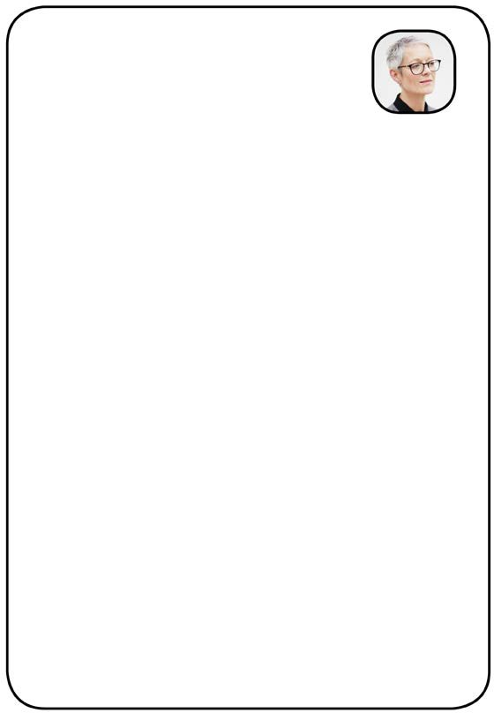

Charlotte Anderson

SERVICE CREW

(212) 555 - 5555

[yourname@mail.com](mailto:yourname@mail.com)

[www.yourwebsite.com](http://www.yourwebsite.com/)

your location

**S K I L L S**

* Serving Proficiency
* Food Ingredients
* Event Set-Up
* Strong Judgement
* Observation Skills
* Logistics

**L A N G U A G E S**

Fluent in English + German Conversation in Spanish