[email@email.com](https://resume.io/resume-templates/?id=cpdokyF1)

**Training Merchandiser**

**Cocsas Florida Campus**

Oct. 2016 - Sep. 2014

• Completed 18 months of training

Copywright by ResumeViking 2022

[60 Word Templates](https://www.resumeviking.com/templates/word/)

[Resume Tool](https://resume.io/resume-templates/?id=cpdokyF1)

**Merchandiser**

**New York Haays Department Store**

Dec. 2016 - Nov. 2018

* Analyzed information and recommended actions and sales patterns
* Assisted in interpreting open-to-buy, sales plan changes and markdown events
* Delivered educational materials to the store for training new employees
* Developed and built cooperative working relationships
* Developed, executed, and tracked weekly, monthly, and quarterly forecasts and results for merchandising experiences and product categories
* • Maintained aisle cleanliness and shop-ability so that merchandise is accessible

**Merchandiser**

**Brooklyn Retail**

Jan. 2018 - Dec. 2020

* Responsible for managing and directing all merchandise activities of a $480M Home Fashions and Household Goods business in 750 stores and supporting 12 categories of product and built productive relationships with each
* Collaborated with cross functional team members to develop individual action plans for each store to meet stated business deliverables and "KPI"s.

• Participated, created, and supported in-store events related to new store openings, new product launches, and seasonal events.

**E D U C A T I O N**

Diploma in Retail Administration / Florida University / Jacksonville 2000 - 2005

Bachelors in Marketing / Texas

University / Austin 2006 - 2011

**W O R K E X P E R I E N C E**

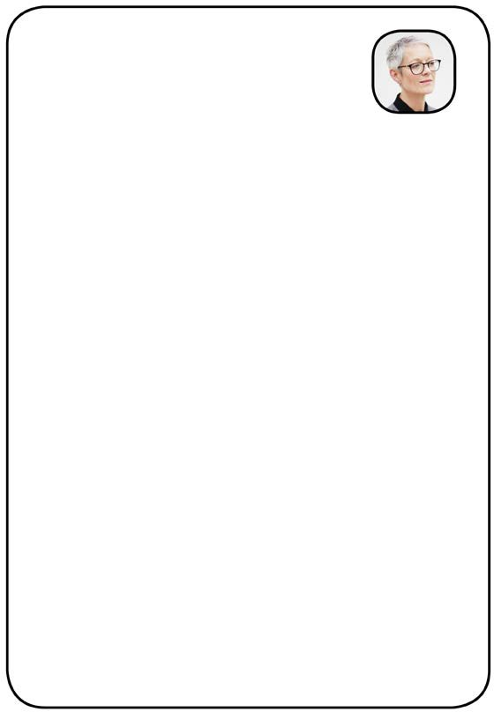

Charlotte Anderson

Merchandiser

(212) 555 - 5555

[www.yourwebsite.com](http://www.yourwebsite.com/)

your location

**S K I L L S**

* Stocking
* Aisle Layout
* Promotion
* Window Dressing
* Garment Selection
* Purchase Orders

**L A N G U A G E S**

Fluent in English + German Conversation in Spanish